Picture | Name | Details
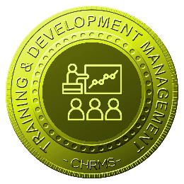 | Main :  TRAINING & DEVELOPMENT MANAGEMENT | Manages employee training, development, and capability building through structured planning, scheduling, execution, and evaluation, ensuring skills alignment, compliance readiness, continuous learning, and measurable workforce development supporting organizational performance, safety requirements, and long-term talent growth strategies.
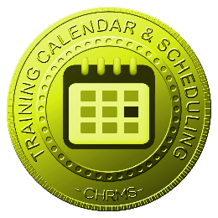 | TRAINING CALENDER & SCHEDULING | Provides centralized planning of training calendars and schedules, enabling HR and managers to organize sessions, allocate resources, avoid conflicts, and ensure employees receive timely training aligned with operational needs and workforce development plans.
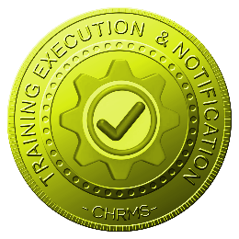 | TRAINING EXECUTION & NOTIFICATION | Manages training execution processes including attendance tracking, participant confirmation, and automated notifications, ensuring employees receive timely reminders, clear instructions, and accurate records of training participation and completion.
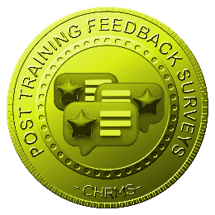 | POST TRAINING FEEDBACK SURVEY | Collects structured post-training feedback through surveys to evaluate training effectiveness, relevance, and delivery quality, supporting continuous improvement, informed program adjustments, and data-driven decisions on future training initiatives.
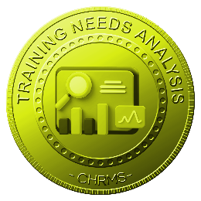 | TRAINING NEEDS ANALYSIS | Analyzes employee skills, performance gaps, and competency requirements using data from appraisals and roles, enabling identification of training priorities to support workforce readiness, capability building, and strategic talent development.
 | TRAINING NEEDS & PLANNING MANAGEMENT | Manages training requirements and annual training plans by role, department, and competency, ensuring structured planning, budget alignment, prioritized development initiatives, and effective utilization of training resources.
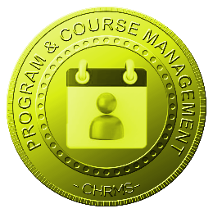 | PROGRAM & COURSE MANAGEMENT | Manages training programs and courses including content, trainers, duration, costs, and delivery methods, ensuring standardized offerings, consistent quality, and alignment with organizational learning objectives.
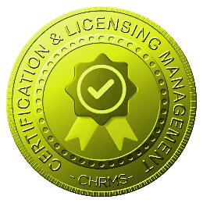 | CERTIFICATION & LICENSING MANAGEMENT | Tracks employee certifications and training-related licenses, including validity and expiry dates, ensuring compliance with regulatory requirements, timely renewals, and readiness for audits and operational assignments.
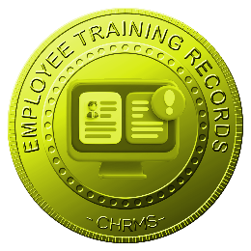 | EMPLOYEE TRAINING RECORDS | Maintains comprehensive records of employee training history, attendance, certifications, and outcomes, providing accurate documentation for compliance, performance reviews, skills tracking, and workforce analytics.

