Picture | Name | Details
 | Main :  PAYROLL MODULE | Manages end-to-end payroll processing including salary calculation, deductions, statutory contributions, disbursements, and reporting, ensuring accuracy, compliance, confidentiality, and timely payments while supporting scalable payroll operations across multiple entities, branches, pay cycles, and diverse workforce structures.
 | PAYROLL RUN & CALCULATION | Automates payroll runs and salary calculations based on attendance, overtime, allowances, deductions, and approved inputs, ensuring accurate, consistent, and timely payroll processing while minimizing errors and supporting multiple pay cycles and organizational structures.
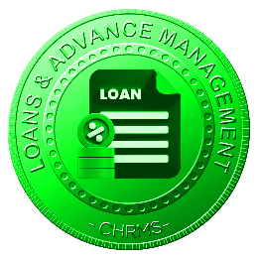 | LOAN & ADVANCE MANAGEMENT | Manages employee loans and salary advances, including eligibility, approval, disbursement, repayment schedules, and balance tracking, ensuring transparent deductions, accurate records, policy compliance, and controlled financial exposure for both employees and the organization.
 | BONUSES & INCENTIVE MANAGEMENT | Supports calculation and payment of bonuses, commissions, and incentives based on defined rules, performance results, and eligibility criteria, ensuring fairness, transparency, and alignment with compensation strategies and organizational performance objectives.
 | DEDUCTION & CONTRIBUTION MANAGEMENT | Manages statutory and non-statutory deductions and contributions, including taxes, social security, insurance, and other withholdings, ensuring accurate calculations, compliance with regulations, and seamless integration into payroll processing cycles.
 | PAYSLIP RECORDS & REPORTS | Generates secure digital payslips and payroll reports, maintaining historical records for employee access, audit purposes, and management review while supporting compliance, transparency, and accurate payroll documentation across all payroll periods.
 | SALARY & BENEFITS STRUCTURE | Defines and manages salary components and benefits structures by role, grade, and employment type, ensuring consistency, scalability, and alignment with compensation policies and organizational workforce strategies.
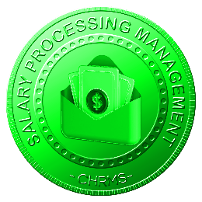 | SALARY PROCESSING MANAGEMENT | Controls payroll processing workflows, approvals, validations, and exception handling, ensuring standardized processes, audit trails, and controlled payroll execution while supporting operational efficiency and governance across payroll operations.
 | STATUTORY & REGULATION MANAGEMENT | Ensures payroll compliance with statutory requirements, labor laws, and tax regulations by managing rates, thresholds, contributions, and reporting obligations, supporting regulatory adherence and audit readiness across jurisdictions.
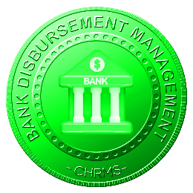 | BANK DISBURSEMENT MANAGEMENT | Manages payroll disbursements through bank integration, supporting batch payments, account validation, payment scheduling, and reconciliation, ensuring timely salary transfers, reduced errors, and secure handling of employee payment information.

