Picture | Name | Details
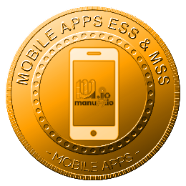 | Main :  MOBILE APPS | Provides secure mobile access to HR services, attendance, claims, approvals, payroll, performance, and communications, enabling employees and managers to perform essential HR tasks anytime, anywhere, improving productivity, responsiveness, transparency, and workforce mobility across on-site, remote, and outstation operations.
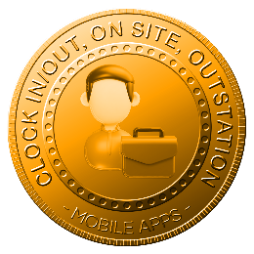 | CLOCK IN/OUT, ON SITE, OUTSTATION | Enables employees to clock in and out via mobile for on-site, remote, or outstation work, capturing accurate attendance records, timestamps, and locations to support flexible work arrangements, accountability, and reliable workforce tracking across various operational scenarios.
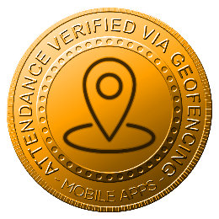 | ATTENDANCE VERIFIED VIA GEOFENCING | Verifies employee attendance using geofencing technology, ensuring clock-in and clock-out occur within approved locations, reducing attendance fraud, improving accuracy, and supporting compliance with company attendance policies across sites, branches, and designated working areas organizationwide.
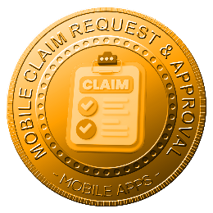 | MOBILE CLAIM REQUEST & APPROVAL | Allows employees to submit claims and managers to review and approve them directly via mobile, streamlining reimbursement workflows, reducing processing delays, improving transparency, and enabling faster decision-making without dependency on desktop systems or manual paperwork processes.
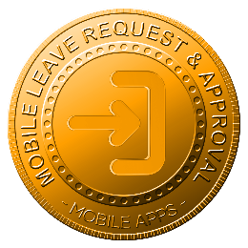 | MOBILE LEAVE REQUEST & APPROVAL | Enables employees to apply for leave and managers to approve or reject requests via mobile, ensuring real-time visibility of leave balances, schedules, and approvals while supporting faster decisions, reduced administration, and improved workforce planning efficiency across teams.
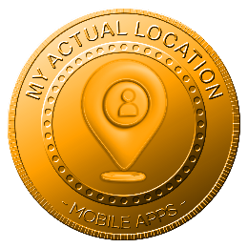 | MY ACTUAL LOCATION | Displays the employee’s actual working location during attendance activities, supporting location-based validation, operational visibility, safety monitoring, and accurate workforce tracking for mobile, field, remote, and outstation employees during official working hours.
 | MOBILE CLAIM SUBMISSION | Allows employees to submit claims via mobile by capturing receipts, documents, and details instantly, reducing delays, improving accuracy, and enabling faster reimbursement processing through integrated approval workflows and centralized claim records management.
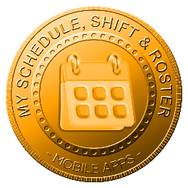 | MY SCHEDULE, SHIFT & ROSTER | Provides mobile access to personal schedules, assigned shifts, and rosters, enabling employees to view updates in real time, plan work commitments, and reduce miscommunication regarding working hours, duty changes, and shift arrangements.
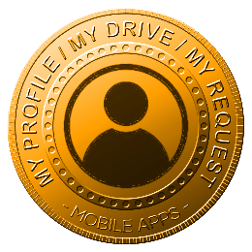 | MY PROFILE / DRIVE / MY REQUEST | Allows employees to access personal profiles, HR documents, digital drive, and submitted requests via mobile, ensuring convenient self-service, updated information visibility, and reduced dependency on HR for routine administrative tasks.
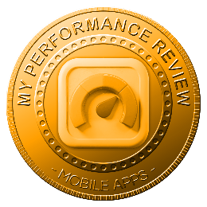 | MY PERFORMANCE REVIEW | Provides mobile access to performance reviews, KPIs, appraisal results, and feedback, enabling employees to monitor progress, understand evaluations, and engage with performance management processes anytime without reliance on desktop systems.
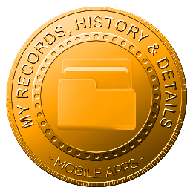 | MY RECORDS, HISTORY & DETAILS | Enables employees to view personal records, employment history, attendance logs, leave history, and HR details via mobile, ensuring transparency, data accessibility, and improved trust in HR information accuracy.
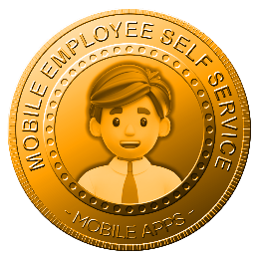 | MOBILE EMPLOYEE SELF SERVICE | Delivers full Employee Self Service functionality on mobile, allowing employees to manage attendance, leave, claims, documents, payroll, and requests conveniently, improving engagement, efficiency, and independence in daily HR interactions.
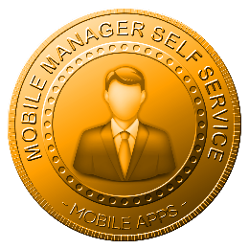 | MOBILE MANAGER SELF SERVICE | Empowers managers with mobile tools to review, approve, reject, and monitor employee requests, attendance, performance, and team data, enabling faster decisions, improved oversight, and effective people management while on the move.
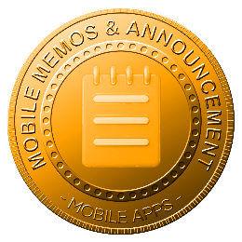 | HR MOBILE MEMOS & ANNOUNCEMENT | Delivers HR memos, announcements, and official communications directly to employee mobile devices, ensuring timely information dissemination, consistent messaging, and improved engagement without reliance on emails or manual communication channels.
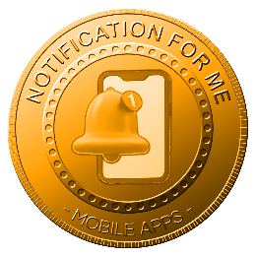 | NOTIFICATION FOR ME | Provides real-time mobile notifications for approvals, reminders, attendance actions, payroll availability, announcements, and compliance alerts, ensuring employees and managers stay informed and responsive to important HR-related events.
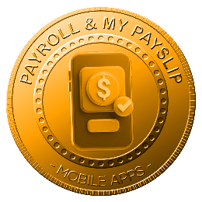 | PAYROLL & MY PAYSLIP | Allows employees to securely access payroll information and download payslips via mobile, improving transparency, confidentiality, and convenience while reducing routine payroll inquiries to HR departments.
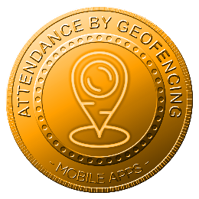 | ATTENDANCE BY GEOFENCING | Supports attendance recording using geofencing validation on mobile devices, ensuring employees clock attendance within approved locations, improving accuracy, preventing misuse, and supporting location-based workforce governance.
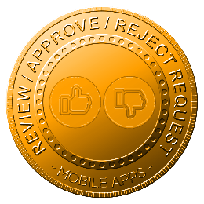 | REVIEW / APPROVAL / REJECT REQUEST | Enables authorized users to review, approve, or reject HR requests via mobile, ensuring faster turnaround times, transparent decision tracking, and uninterrupted workflows regardless of physical location or working hours.
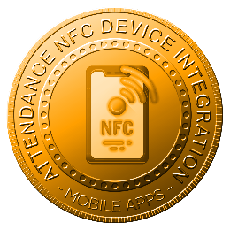 | ATTENDANCE BY NFC INTEGRATE WITH DEVICES | Supports attendance recording via NFC-enabled mobile devices integrated with physical readers, ensuring fast, secure, and contactless attendance capture while supporting integration with on-site access control and attendance hardware systems.

