Picture | Name | Details
 | Main :  MSS - MANAGER SELF SERVICE MODULE | Empowers managers with self-service tools to manage team operations, approvals, performance, compliance, scheduling, and workforce requests, enabling faster decisions, improved oversight, reduced HR dependency, and effective people management aligned with organizational policies and operational requirements across departments.
 | ROTATIONAL & DUTY TRAVEL MANAGEMENT | Enables managers to plan, approve, and monitor rotational duties and official travel assignments, ensuring workforce availability, policy compliance, cost visibility, and clear scheduling for teams involved in shifts, fieldwork, or multi-location operational requirements.
 | ALLOWANCE & BENEFITS VERIFICATION | Allows managers to verify employee allowances and benefits eligibility based on roles, assignments, attendance, and policies, ensuring accurate entitlement validation, controlled costs, and alignment with approved compensation and benefits structures.
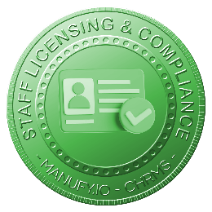 | STAFF LICENSING & COMPLIANCE | Provides managers visibility to staff licenses, certifications, and compliance status, enabling verification of eligibility, monitoring expiries, and ensuring team members meet regulatory and operational requirements before assignment or deployment.
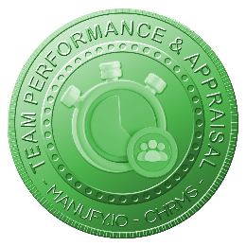 | TEAM PERFORMANCE & APPRAISAL | Enables managers to review team KPIs, performance results, and appraisal records, supporting fair evaluations, constructive feedback, development planning, and alignment between team outcomes and organizational performance objectives.
 | TEAM SCHEDULE & ATTENDANCE | Allows managers to view and manage team schedules, shifts, rosters, and attendance records, ensuring adequate coverage, attendance compliance, and effective workforce planning across daily operations and multiple work locations.
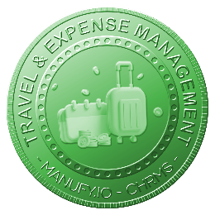 | TRAVEL & EXPENSE MANAGEMENT | Enables managers to review, approve, and monitor team travel requests and expenses, ensuring compliance with policies, cost control, timely approvals, and accurate tracking of business-related expenditures.
 | DICIPLINARY ACTION MANAGEMENT | Supports managers in initiating, reviewing, and managing disciplinary actions according to defined policies, ensuring documentation, fairness, confidentiality, and consistent enforcement across teams and organizational units.
 | EMPLOYEE / MANPOWER INWUIRY / REQUISITION | Allows managers to submit and track employee inquiries and manpower requisitions, ensuring staffing requests are justified, documented, aligned with operational needs, and routed through proper approval workflows.
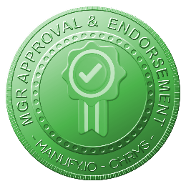 | MANAGEMENT APPROVAL & ENDORSEMENT | Provides managers with structured tools to review, approve, reject, or endorse HR-related requests, ensuring timely decisions, accountability, audit trails, and uninterrupted operational workflows across departments and organizational levels.

