Picture | Name | Details
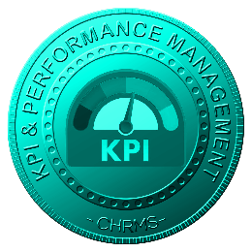 | Main :  KPI & PERFORMANCE MANAGEMENT | Manages employee performance, KPIs, competencies, and potential through structured evaluations, improvement plans, and analytics, enabling transparent assessments, continuous development, fair promotions, succession planning, and alignment between individual performance outcomes and organizational strategic objectives across departments roles locations enterprisewide.
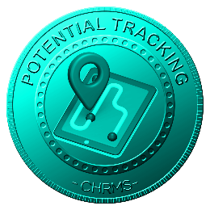 | POTENTIAL TRACKING | Tracks employee potential indicators, career readiness, and growth capacity using structured criteria and performance data, enabling early identification of high-potential talent, targeted development planning, leadership pipeline visibility, and informed succession decisions across critical roles departments locations functions organizationwide.
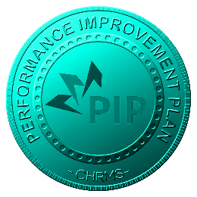 | PERFORMANCE IMPROVEMENT PLAN | Manages structured Performance Improvement Plans by defining objectives, timelines, actions, and reviews, enabling managers and employees to address underperformance constructively, track progress transparently, ensure fairness, documentation, and compliance with HR policies across departments roles locations governance standards organizationwide.
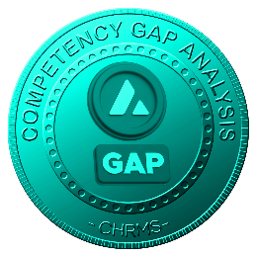 | COMPETENCY GAP ANALYSIS | Analyzes required versus existing employee competencies by role, grade, and function, identifying skill gaps using performance and training data, supporting targeted development plans, workforce readiness, capability building, and strategic talent planning initiatives across departments locations roles organizationwide enterprise.
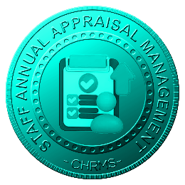 | STAFF ANNUAL APPRAISAL MANAGEMENT | Manages structured annual performance appraisals, evaluations, and reviews based on defined KPIs and competencies, ensuring consistency, transparency, documented outcomes, and fair assessments to support rewards, development planning, promotions, and performance-driven organizational decisions across departments roles cycles locations enterprisewide.
 | PROMOTION & SUCCESSION PLAN | Supports promotion and succession planning by linking performance results, potential assessments, and competency readiness, enabling fair advancement decisions, leadership continuity, risk mitigation, and structured talent pipelines for critical roles and future organizational sustainability across departments locations functions enterprisewide.
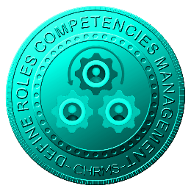 | DEFINE ROLES COMPENTENCIES MANAGEMENT | Defines and manages role-based competency requirements, skills, and behavioral expectations, establishing standardized benchmarks to support recruitment, training, performance evaluation, and career development while ensuring alignment with organizational objectives and operational requirements across departments roles locations governance standards enterprisewide.
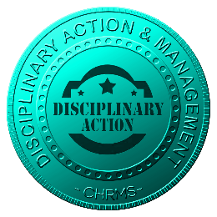 | DICIPLINARY ACTION & MANAGEMENT | Manages disciplinary actions, cases, and outcomes through structured workflows, ensuring fairness, confidentiality, documentation, and policy compliance while providing visibility to authorized parties and supporting consistent governance, corrective actions, and risk management processes across departments roles locations organizationwide enterprise.
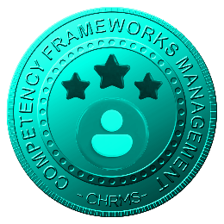 | COMPETENCY FRAMEWORKS MANAGEMENT | Manages organizational competency frameworks defining core, functional, and leadership competencies, enabling standardized assessments, development planning, talent benchmarking, and alignment between workforce capabilities and strategic business objectives across multiple roles and departments locations functions subsidiaries governance standards enterprisewide organizationwide.

