Picture | Name | Details
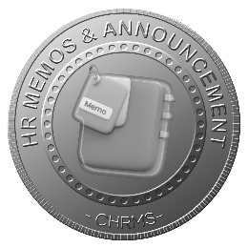 | Main :  HR COMMUNICATION & ANNOUNCEMENT | Manages centralized HR communication, policy updates, company news, and announcements, ensuring timely, transparent, and consistent information delivery to employees, supporting engagement, compliance, awareness of corporate events, and seamless interaction through digital channels and self-service platforms.
 | COMPANY POLICY UPDATE & CIRCULATION | Distributes updated company policies, guidelines, and procedures to employees, ensuring awareness, compliance, acknowledgment tracking, and version control while reducing miscommunication and enabling HR to monitor adherence across all departments and operational locations.
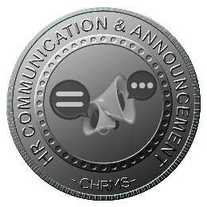 | HR COMMUNICATION & ANNOUNCEMENT | Enables HR to send structured announcements, notices, and official communications to employees via multiple channels, ensuring transparency, engagement, and timely dissemination of important information across teams, branches, and the entire workforce.
 | COMPANY EVENTS & MILESTONE | Manages notifications and information about company events, achievements, anniversaries, and milestones, ensuring employees are informed, engaged, and able to participate in corporate activities, fostering organizational culture and employee connection.
 | COMPANY NEWS & UPDATES | Delivers internal news, updates, and important corporate developments directly to employees, keeping them informed about organizational changes, achievements, or operational developments, supporting engagement, awareness, and consistent messaging across all teams.
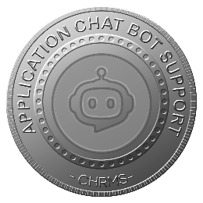 | APPLICATION CHATBOT SUPPORT | Provides interactive chatbot assistance within the HR application, enabling employees to quickly access information, HR policies, announcements, FAQs, and self-service actions, improving response times, reducing HR workload, and enhancing user experience across platforms.

