Picture | Name | Details
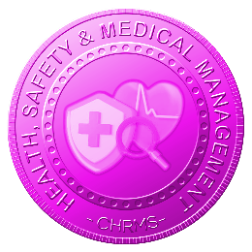 | Main :  HEALTH, SAFETY & MEDICAL MANAGEMENT | Manages employee health, safety, and medical-related information through structured reporting, records, and compliance tracking, ensuring workplace safety, regulatory adherence, risk mitigation, and accurate documentation to support organizational well-being, audit readiness, and responsible workforce governance practices.
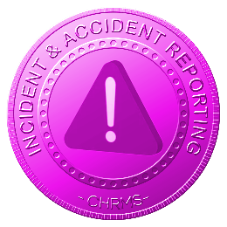 | INCIDENT & ACCIDENT REPORTING MANAGEMENT | Manages reporting and documentation of workplace incidents and accidents, capturing details, evidence, actions taken, and investigation outcomes, ensuring timely reporting, compliance with safety regulations, risk analysis, corrective actions, and continuous improvement of workplace safety standards.
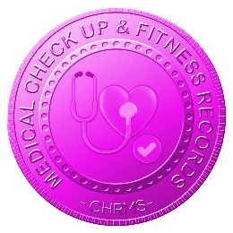 | MEDICAL CHECK UP & FITNESS RECORDS | Maintains employee medical check-up results and fitness-for-work records, enabling monitoring of health status, job suitability, and compliance with occupational health requirements while ensuring confidentiality, controlled access, and readiness for audits and operational deployment decisions.
 | SAFETY TRAINING & CERTIFICATION RECORDS | Tracks employee safety training participation, certifications, and validity periods, ensuring workforce readiness, regulatory compliance, timely renewals, and accurate records to support safe operations, audits, and assignment eligibility across high-risk or regulated work environments.
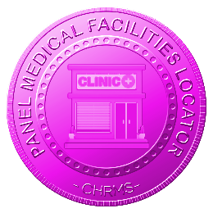 | PANEL & PUBLIC MEDICAL FACILITIES LOCATOR | Maintains a database of panel and public clinics or hospitals, with geolocation to identify the nearest facilities to employees, enabling timely medical care, emergency response, health compliance tracking, and improved workforce well-being across multiple sites and branches.
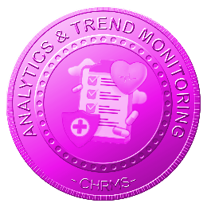 | ANALYTICS & TREND MONITORING | Analyzes incidents, near-misses, medical records, training completion, and safety data to identify patterns, forecast risks, measure performance, and support proactive decision-making, enabling HR and management to implement preventive measures, improve safety culture, and enhance operational health governance.
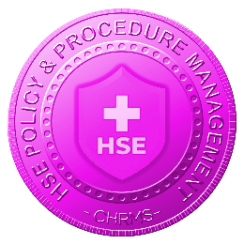 | HSE POLICY & PROCEDURE MANAGEMENT | Centralizes workplace health, safety, and environmental policies, procedures, and manuals with version control, access management, and audit readiness, ensuring employees are informed, trained, and compliant while supporting regulatory adherence and organizational governance requirements.
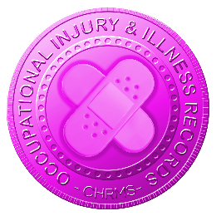 | OCCUPATIONAL INJURY & ILLNESS RECORDS | Maintains detailed records of workplace injuries, illnesses, treatments, and outcomes, enabling accurate reporting, statutory compliance, claims management, trend analysis, and preventive action planning while supporting employee health monitoring and operational safety oversight.

