Picture | Name | Details
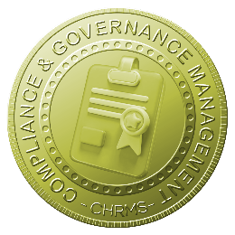 | Main :  COMPLIANCE & GOVERNANCE MANAGEMENT | Centralizes management of employee work permits, licenses, certifications, and compliance requirements, ensuring regulatory adherence, audit readiness, operational safety, and accurate recordkeeping while supporting timely renewals, risk mitigation, and governance across all organizational departments, roles, and locations.
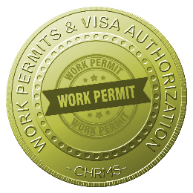 | WORK PERMIT & VISA AUTHORIZATION | Tracks employee work permits, visas, and legal authorizations, including expiry dates and approvals, ensuring regulatory compliance, timely renewals, risk mitigation, audit readiness, and accurate recordkeeping for local and foreign employees across all company operations and subsidiaries.
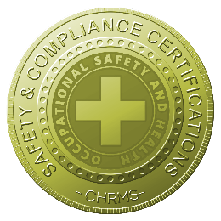 | SAFETY & COMPLIANCE CERTIFICATIONS | Manages employee safety training certifications, compliance courses, and mandatory regulatory requirements, providing reminders for expiry, reporting tools, and centralized access, ensuring workplace safety adherence, reduced risks, and compliance with internal policies and external regulatory standards.
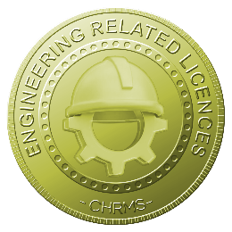 | ENGINEERING RELATED LICENSES | Maintains records of engineering licenses, professional certifications, and technical authorizations, tracking validity, renewal schedules, and compliance with statutory and industry standards, supporting operational safety, audit readiness, and accountability for engineering personnel and departmental operations.
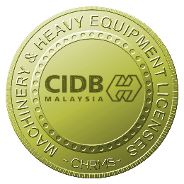 | MACHINERY & HEAVY EQUIPMENT LICENSES | Tracks licenses, permits, and certifications for operating machinery and heavy equipment, ensuring that employees meet safety standards, legal requirements, and company policies while reducing operational risks, supporting compliance audits, and improving safety governance.
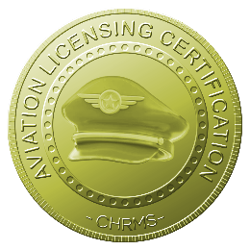 | AVIATION LICENSING CERTIFICATION | Manages aviation-specific licenses and certifications for pilots, technicians, and aviation staff, including renewal tracking and compliance monitoring, ensuring adherence to regulatory authorities, safety standards, and operational governance within aviation operations.
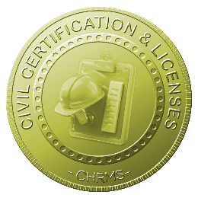 | CIVIL CERTIFICATION & LICENSES | Maintains civil engineering certifications, construction permits, and related licenses, ensuring employees and contractors comply with legal standards, safety regulations, and professional requirements while supporting audit readiness, operational governance, and workforce accountability.
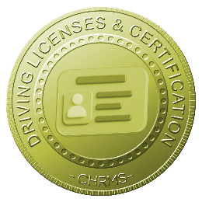 | DRIVING LICENSES & CERTIFICATION | Tracks employee driving licenses, endorsements, and related certifications, monitoring validity and renewal reminders, ensuring compliance with traffic laws, internal safety policies, and operational requirements while mitigating liability and maintaining proper recordkeeping.

