Picture | Name | Details
 | Main :  APPLICATION FEATURES | Provides essential system functionalities to enhance user experience, streamline operations, and integrate attendance, notifications, and alerts, ensuring accurate tracking, timely communication, seamless system interactions, and improved workforce efficiency across mobile, ESS, MSS, and desktop platforms.
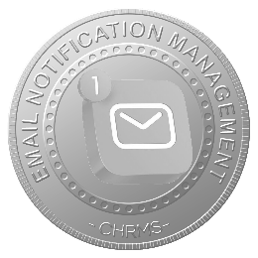 | EMAIL NOTIFICATION MANAGEMENT | Manages automated email notifications for approvals, reminders, alerts, announcements, and system updates, ensuring timely communication, improved workflow responsiveness, and engagement of employees and managers while reducing dependency on manual follow-ups and supporting audit tracking.
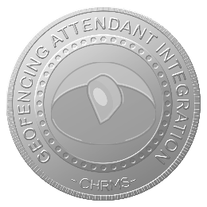 | GEOFENCING ATTENDANT INTEGRATION | Integrates attendance tracking via geofencing technology, ensuring employees clock in and out within authorized locations, enhancing attendance accuracy, preventing fraud, supporting compliance, and enabling management to monitor workforce location-based attendance across multiple sites or field operations.
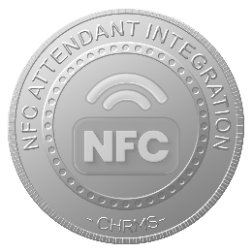 | NFC ATTENDANT INTEGRATION | Supports contactless attendance capture using NFC-enabled devices, allowing employees to record work hours seamlessly, integrating with payroll and HR systems, improving accuracy, reducing administrative errors, and providing secure, real-time attendance data.
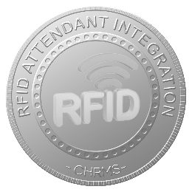 | RFID ATTENDANT INTEGRATION | Enables attendance tracking via RFID cards or tags, allowing employees to record clock-in/out efficiently, providing secure, real-time attendance data, supporting payroll and HR workflows, and reducing manual processing errors across operational sites.
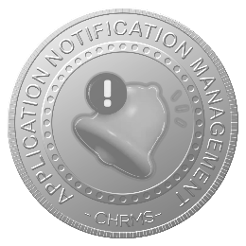 | APPLICATION NOTIFICATION MANAGEMENT | Manages in-app notifications for approvals, requests, reminders, system alerts, and updates, ensuring employees and managers receive timely, actionable information, improving response times, workflow efficiency, and overall engagement with the HRMS platform.
 | ATTENDANCE DEVICE INTEGRATION | Integrates various attendance devices including biometric scanners, fingerprint readers, NFC, RFID, and facial recognition systems with the HRMS, enabling real-time, accurate attendance capture, automated payroll integration, secure data management, and streamlined workforce tracking across multiple locations and operational sites.

