Picture | Name | Details
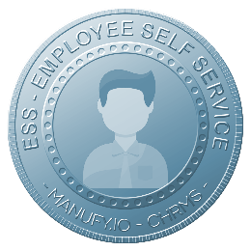 | Main :  ESS – EMPLOYEE SELF SERVICE | The Employee Self Service (ESS) module in Manufy.io CHRMS empowers employees to independently manage their personal HR-related information and requests through a centralized digital platform. This reduces administrative workload, improves data accuracy, and enhances transparency across the organization
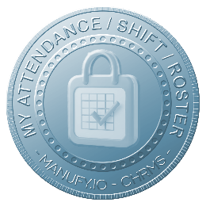 | MY ATTENDANCE / SHIFT / ROSTER | Allows employees to view attendance records, assigned shifts, and rosters in real time, including clock-in history, working hours, and schedule changes, ensuring transparency, accuracy, and better workforce planning without frequent HR intervention and improved employee accountability daily visibility.
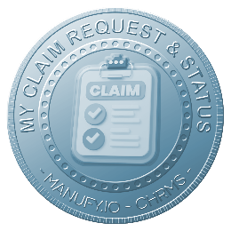 | MY CLAIM REQUEST & PROGRESS STATUS | Enables employees to submit expense and reimbursement claims digitally, attach supporting documents, and track approval progress transparently, reducing paperwork, processing time, and manual follow-ups while ensuring accurate records and faster claim settlements across departments, improving efficiency and trust.
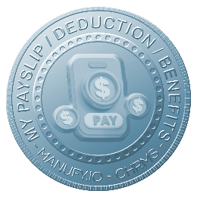 | My PAYSLIP / DEDUCTION / BENEFITS | Provides secure self-access to monthly payslips, salary breakdowns, deductions, and benefits information, allowing employees to download historical records anytime, improve payroll transparency, and reduce dependency on HR for routine salary-related inquiries while enhancing confidentiality, trust, accuracy, and compliance.
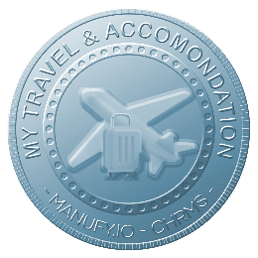 | MY TRAVEL & ACCOMONDATION | Allows employees to submit travel and accommodation requests, view itineraries, and track approvals within a centralized system, ensuring organized travel planning, cost control, policy compliance, and clear visibility for both employees and management during official business trips companywide.
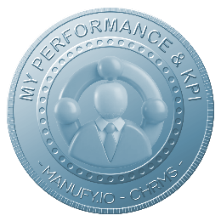 | MY PERFORMANCE & KPI | Displays individual KPIs, performance targets, appraisal results, and historical evaluations, enabling employees to monitor progress, understand expectations, and align personal performance with organizational objectives and continuous improvement initiatives through transparent metrics, structured reviews, timely feedback, accountability, and clarity.
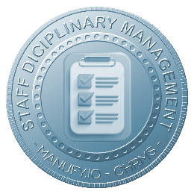 | MY DICIPLINARY MANAGEMENT | Provides controlled visibility of disciplinary notices, records, and resolution status, ensuring confidentiality, fairness, and transparency while allowing employees to understand issues, actions taken, and outcomes according to company policies and governance standards without misinformation, disputes, escalation, confusion, or bias.
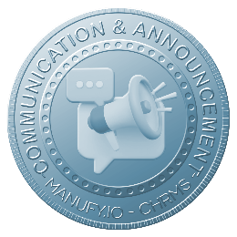 | COMMUNICATION & ANNOUNCEMENT | Centralizes company announcements, HR notices, and internal communications into a single platform, ensuring timely information delivery, consistent messaging, reduced email dependency, and better alignment between management, departments, and employees across all locations, shifts, teams, roles, operations, and functions.
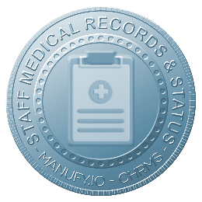 | STAFF MEDICAL RECORDS & STATUS | Allows secure management and viewing of employee medical records, medical leave history, and health status, subject to access controls, supporting confidentiality, regulatory compliance, and informed HR decision-making when required without exposing sensitive data, ensuring privacy, trust, security, and accountability.
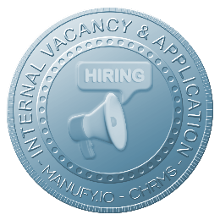 | INTERNAL VACANCY & APPLICATION | Enables employees to view internal job vacancies and submit applications digitally, supporting career development, internal mobility, and fair talent opportunities while reducing external recruitment costs and improving employee retention through transparent processes, faster selection, engagement, morale, loyalty, and growth.
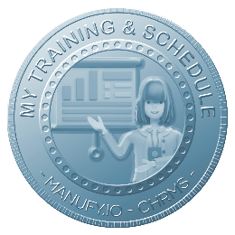 | MY TRAINING & SCHEDULE | Displays assigned training programs, schedules, attendance status, and training history, enabling employees to plan participation, track skill development, and ensure completion of mandatory and professional development courses aligned with role requirements, certifications, compliance, competency growth, performance, readiness, succession.
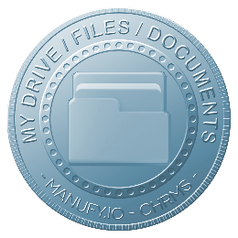 | MY DRIVE, FILES & DOCUMENTATION | Provides a personal digital storage space for employees to access, upload, and manage HR-related documents such as contracts, letters, certificates, and policies securely within a centralized and controlled document environment improving accessibility, organization, version control, security, retrieval, efficiency.
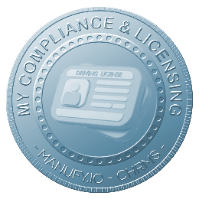 | MY COMPLIANCE & LICENSING | Allows employees to monitor professional licenses, certifications, compliance requirements, and expiry dates, with automated reminders to support timely renewals, regulatory compliance, and reduced operational risk for the organization across regulated roles, audits, inspections, workforce, governance, safety, continuity, accountability.
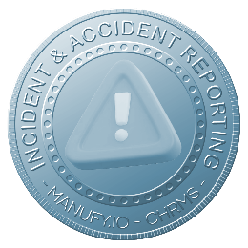 | INCIDENT & ACCIDENT REPORTING | Enables employees to report workplace incidents and accidents digitally, including descriptions, evidence, and immediate actions taken, ensuring timely reporting, proper investigation, regulatory compliance, risk mitigation, safety awareness, audit readiness, and centralized records to support corrective actions and continuous workplace safety improvement.

