Picture | Name | Details
 | Main :  EIS - EMPLOYEE INFORMATION SYSTEM | Serves as the centralized master system for managing complete employee information, organizational structures, and workforce data, ensuring accuracy, consistency, secure access, and reliable reporting to support HR operations, compliance, analytics, and strategic workforce planning decisions organizationwide..
 | EMPLOYEE DETAILS RECORDS DATA BASED | Maintains a centralized and secure database of employee personal, employment, contractual, and historical records, ensuring data accuracy, easy retrieval, controlled access, and compliance with HR policies, audit requirements, and data protection regulations across the organization.
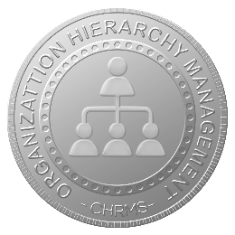 | ORGANIZATION HIERACHY MANAGEMENT | Manages organizational structures, reporting lines, and supervisory relationships dynamically, enabling clear visibility of roles, departments, and authority levels while supporting approval workflows, workforce planning, performance management, and organizational change management processes efficiently and accurately.
 | ORGANIZATION SUBSIDIARIES & BRANCHES | Supports management of employees across multiple subsidiaries, branches, and locations within a single system, enabling centralized oversight, localized operations, consistent HR policies, and accurate reporting for multi-entity and multi-site organizational environments.
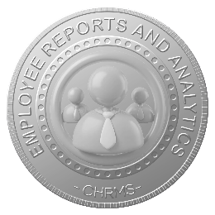 | EMPLOYEE REPORTS AND ANALYTICS | Provides comprehensive employee reports and analytics covering headcount, demographics, turnover, tenure, and workforce trends, enabling data-driven HR decisions, compliance reporting, management insights, and strategic workforce planning based on accurate, real-time employee data.
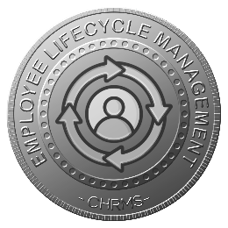 | EMPLOYEE LIFECYCLE MANAGEMENT | Manages the complete employee journey from onboarding, confirmation, promotion, transfer, and role changes through separation, ensuring accurate historical records, process consistency, audit readiness, and reliable workforce data to support HR operations, compliance, and strategic workforce planning.
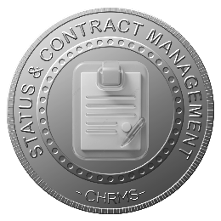 | EMPLOYEE STATUS & CONTRACT MANAGEMENT | Tracks employment status, contract types, probation periods, renewals, and end dates, enabling HR to monitor changes, ensure policy compliance, trigger alerts, and support workforce planning while reducing risks related to expired contracts or incorrect employee status records.
 | ROLE. GRADE & JOB CLASSIFICATION | Defines and manages standardized roles, grades, designations, and job classifications, supporting structured compensation, benefits eligibility, performance evaluation, internal equity, and clear organizational structure alignment across departments, locations, subsidiaries, and multi-entity business environments organizationwide.
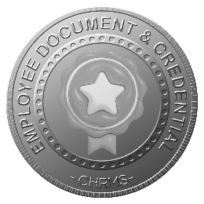 | EMPLOYEE DOCUMENT & CREDENTIAL | Stores, manages, and secures employee documents, certifications, licenses, and credentials with access controls, version tracking, and expiry monitoring, ensuring compliance, audit readiness, and easy retrieval of critical employment records while protecting sensitive information and maintaining data integrity.
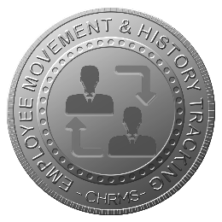 | EMPLOYEE MOVEMENT & HISTORY TRACKING | Records all employee movements including promotions, transfers, salary adjustments, department changes, and reporting line modifications, providing a complete audit trail, historical reference, and accurate workforce data to support HR decisions, compliance, performance reviews, succession planning, and organizational transparency.

