Picture | Name | Details
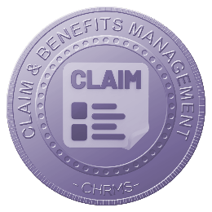 | Main :  CLAIM & BENEFITS MANAGEMENT | Provides centralized management of employee claims and benefits, covering configuration, submission, approval, utilization tracking, and reporting, ensuring fair benefits administration, cost control, policy compliance, transparency, and efficient processing aligned with organizational compensation and employee welfare strategies.
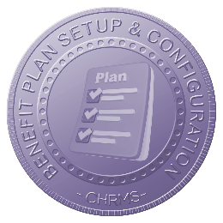 | BENEFITS PLAN SETUP & CONFIGURATION | Allows HR to define, configure, and manage benefits plans, eligibility rules, limits, and policies by employee category, ensuring structured benefits administration, compliance with company policies, and consistent application across departments, grades, employment types, locations, and organizational structures.
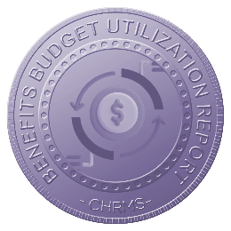 | BENEFITS BUDGET UTILIZATION REPORT | Provides detailed reports on benefits budget allocation, utilization, and remaining balances, enabling HR and finance to monitor spending patterns, identify overutilization risks, and ensure benefits costs remain within approved budgets and financial planning objectives.
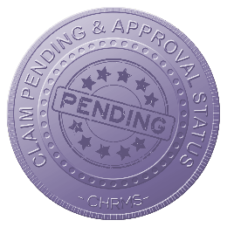 | CLAIM PENDING & APPROVAL STATUS | Displays real-time status of submitted claims, including pending, approved, rejected, and paid stages, enabling employees and HR to track progress transparently, reduce follow-ups, improve turnaround time, and ensure accountability across approval workflows and management levels.
 | CLAIM REPORTS & ANALYTICS | Generates structured reports and analytics on claim types, frequencies, amounts, trends, and exceptions, supporting cost analysis, policy evaluation, fraud detection, and data-driven improvements in benefits and reimbursement management across the organization.
 | NEW HIRE BENEFITS CONFIGURATION | Enables automatic assignment of benefits plans to new hires based on role, grade, employment type, or probation status, ensuring accurate entitlement setup, faster onboarding, policy compliance, and reduced manual intervention by HR teams.
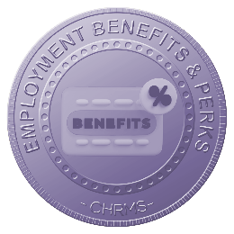 | EMPLOYMENT BENEFITS & PERKS | Manages statutory and non-statutory employment benefits and perks, including allowances, insurance, wellness programs, and incentives, ensuring visibility, consistency, cost tracking, and alignment with compensation strategy to enhance employee satisfaction, retention, and organizational competitiveness.

3

