Picture | Name | Details
 | Main :  MANPOWER / LABOR BUDGET MANAGEMENT | Provides centralized control for planning, allocating, and monitoring manpower and labor-related budgets, including salaries, allowances, overtime, and workforce costs, ensuring accurate forecasting, cost optimization, budget discipline, and alignment with organizational workforce planning strategies and financial objectives.
 | STAFF POSITION BUDGET BASED | Allows HR to allocate budgets based on approved staff positions, headcount, and role classifications, ensuring workforce planning aligns with financial limits while supporting hiring control, vacancy planning, and cost justification for each position across departments and organizational structures.
 | HR BUDGET INITIALIZATION | Enables structured setup of HR budgets at the beginning of each financial cycle, defining baseline allocations, assumptions, and parameters to ensure consistency, governance, and accurate planning across manpower, benefits, training, and operational HR expenditures organizationwide.
 | NON SALARY BUDGETING | Supports budgeting for non-salary HR expenses such as training, recruitment, uniforms, welfare, insurance, travel, and employee engagement activities, ensuring complete visibility, cost tracking, and controlled spending beyond payroll-related costs within approved HR financial plans.
 | BUDGET AUDIT TRAIL & SIGNATURES | Records all budget changes, approvals, revisions, and digital signatures with timestamps, ensuring full auditability, accountability, and compliance while supporting internal controls, financial governance, and transparent approval workflows across HR, finance, and management levels organizationwide.
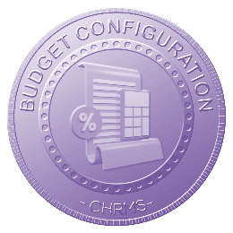 | BUDGET CONFIGURATION | Allows flexible configuration of budget rules, limits, categories, approval flows, and fiscal periods, enabling organizations to adapt HR budgeting structures to company policies, financial models, and operational requirements without complex system customization or manual workarounds.
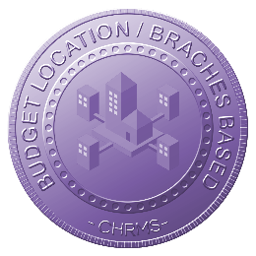 | BUDGET LOCATION / BRANCHES BASED | Supports budget allocation and monitoring by location, branch, or site, enabling decentralized cost control while maintaining centralized oversight, improving accuracy in workforce cost distribution and supporting multi-branch or multi-site organizational budgeting structures.
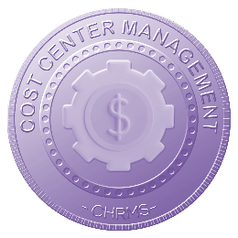 | COST CENTER MANAGEMENT | Enables assignment and tracking of HR budgets by cost center, department, or project, ensuring precise cost attribution, accountability, and analysis while supporting financial reporting, variance tracking, and informed decision-making across organizational units.
 | BUDGET REPORTING & DASHBOARD | Provides real-time dashboards and structured reports displaying HR budget allocation, utilization, variances, and trends, enabling management to monitor spending performance, identify risks early, and support data-driven workforce and financial planning decisions.
 | BUDGET PLAN & ACTUAL EXPENCESS | Compares planned HR budgets against actual expenses in real time, highlighting variances and trends to support corrective actions, cost control, forecasting accuracy, and continuous improvement in manpower and HR financial management effectiveness.

